**KALLAM HARANADHAREDDY INSTITUTE OF TECHNOLOGY**



**Domain: Salesforce Developer**

**Branch: Information Technology**

**Batch:1**

|  |  |  |
| --- | --- | --- |
| Sekuri Manju Bhargavi | [218x1a1232@khitguntur.ac.in](mailto:218x1a1232@khitguntur.ac.in) | [manjubhargavi5579@gmail.com](mailto:manjubhargavi5579@gmail.com) |
| Bandaru Kesava Ram | [228x5a1202@khitguntur.ac.in](mailto:228x5a1202@khitguntur.ac.in) | [kesavaramwork@gmail.com](mailto:kesavaramwork@gmail.com) |
| Punati Anil Kumar | [208x1a1231@khitguntur.ac.in](mailto:208x1a1231@khitguntur.ac.in) | [anilkumarpunati1234@gmail.com](mailto:anilkumarpunati1234@gmail.com) |
| Shaik Balaji | [208x1a1263@khitguntur.ac.in](mailto:208x1a1263@khitguntur.ac.in) | [skbalaji795@gmail.com](mailto:skbalaji795@gmail.com) |

**Project Title: Pizza Delivery Application**

**1.Project Overview:** Pizza delivery is a service in which a pizzeria or pizza chain delivers a pizza to a customer. An order is typically made either by telephone, or over the internet, in which the customer can request pizza type and size, and other items to be delivered with it, commonly including soft drinks. Pizzas may be delivered in cardboard pizza boxes or delivery bags, and deliveries are made with either an automobile, motorized scooter, or bicycle.

**2.Objectives:**

**Business Goals:**

1. **Increase Sales:**
   * Achieve a 20% increase in orders in the first 3 months.
   * Generate $250,000 in revenue in the first 6 months.
2. **Customer Retention:**
   * Retain 75% of customers after their first order.
   * Increase repeat orders by 30% using personalized marketing.
3. **Operational Efficiency:**
   * Reduce delivery time by 15% within 6 months.
   * Cut customer support response time by 20%.

**Specific Outcomes:**

1. **Salesforce Integration:**
   * Integrate the app with Salesforce to track customer data and orders.
   * Sync customer information between the app and Salesforce.
2. **Order Tracking:**
   * Use Salesforce to track real-time order updates and delivery status.
   * Allow customers to track their orders in real-time via the app.
3. **Customer Engagement:**
   * Set up personalized marketing using Salesforce to send targeted promotions.
   * Use Salesforce to send automated messages for new offers or discounts.
4. **Customer Support:**
   * Use Salesforce to manage customer service requests and resolve issues within 24 hours.
   * Implement a chatbot for quick responses to common questions.
5. **Analytics & Reporting:**
   * Use Salesforce to track key metrics like sales, customer satisfaction, and delivery times.
   * Generate monthly reports on app performance and customer trends.

**3.Salesforce Key Features and Concepts Utilized**

* + Object
  + Tabs
  + Create App
  + Fields & Relationships
  + Record Types
  + Profile
  + User Adoption
  + OWD (Organization Wide Default)
  + Reports
  + Apex Trigger
  + Schedule Apex

**4.Detailed Steps to Solution Design Objects**

### Create a custom object for Customer Detail

**To create an object follow**

1. Click on the Gear Icon? From setup click on object manager
2. Click create, select custom object.
3. Fill in the label as "Customer Detail".
4. Fill in the plural label as "Customer Details".
5. Record name: "Customer Name"
6. Select the data type as "Text".
7. In the Optional Features section, select Allow Reports and Track Field History.
8. In the Deployment Status section, ensure Deployed is selected.
9. In the Search Status section, select Allow Search.
10. In the Object Creation Options section, select these options: Add Notes and Attachments related list to default page layout Launch New Custom Tab Wizard after saving this custom object
11. Leave everything else as is, and click Save.

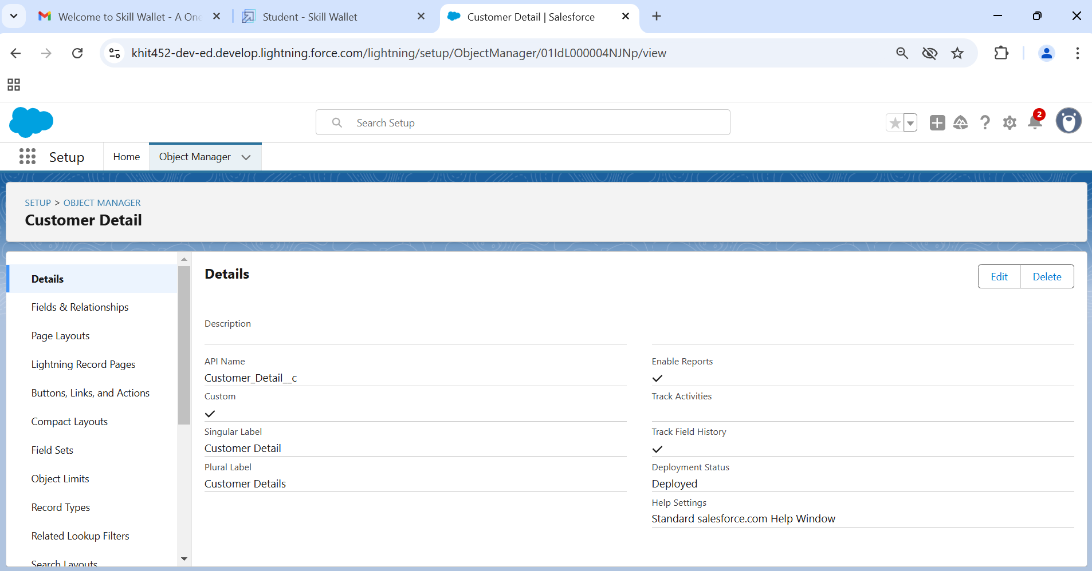

Similarly do the same process for other objects also

**Custom object for Every Day Value**

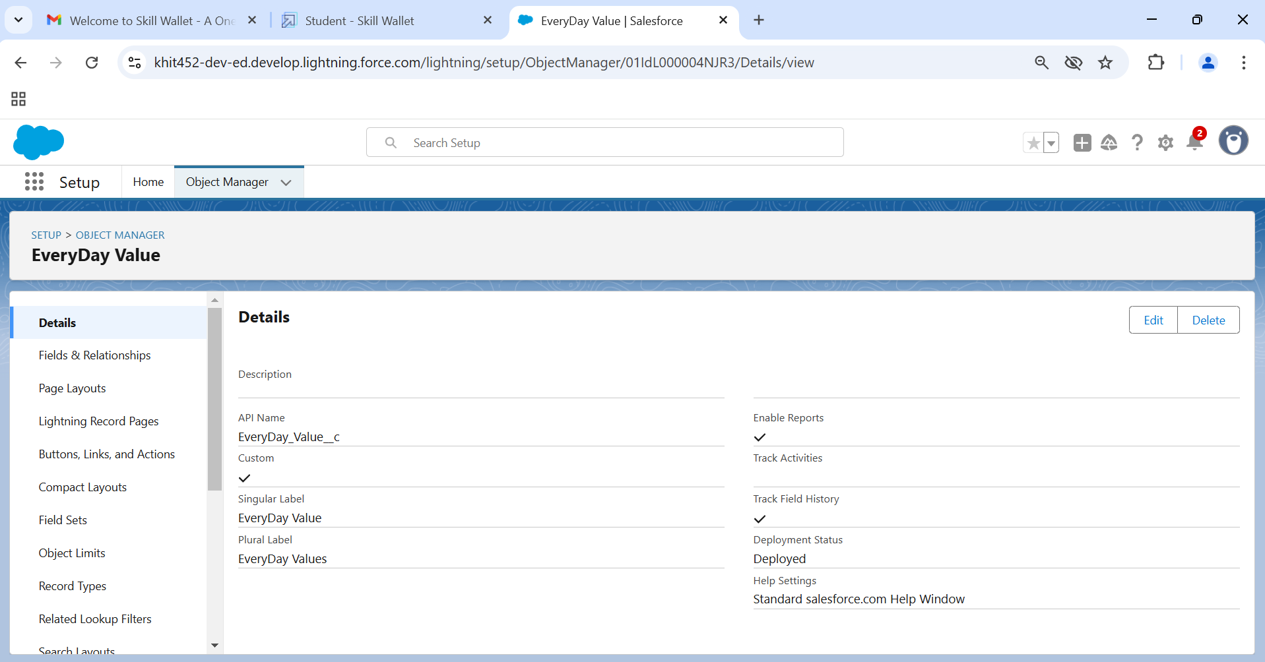

### Custom object for Best Seller

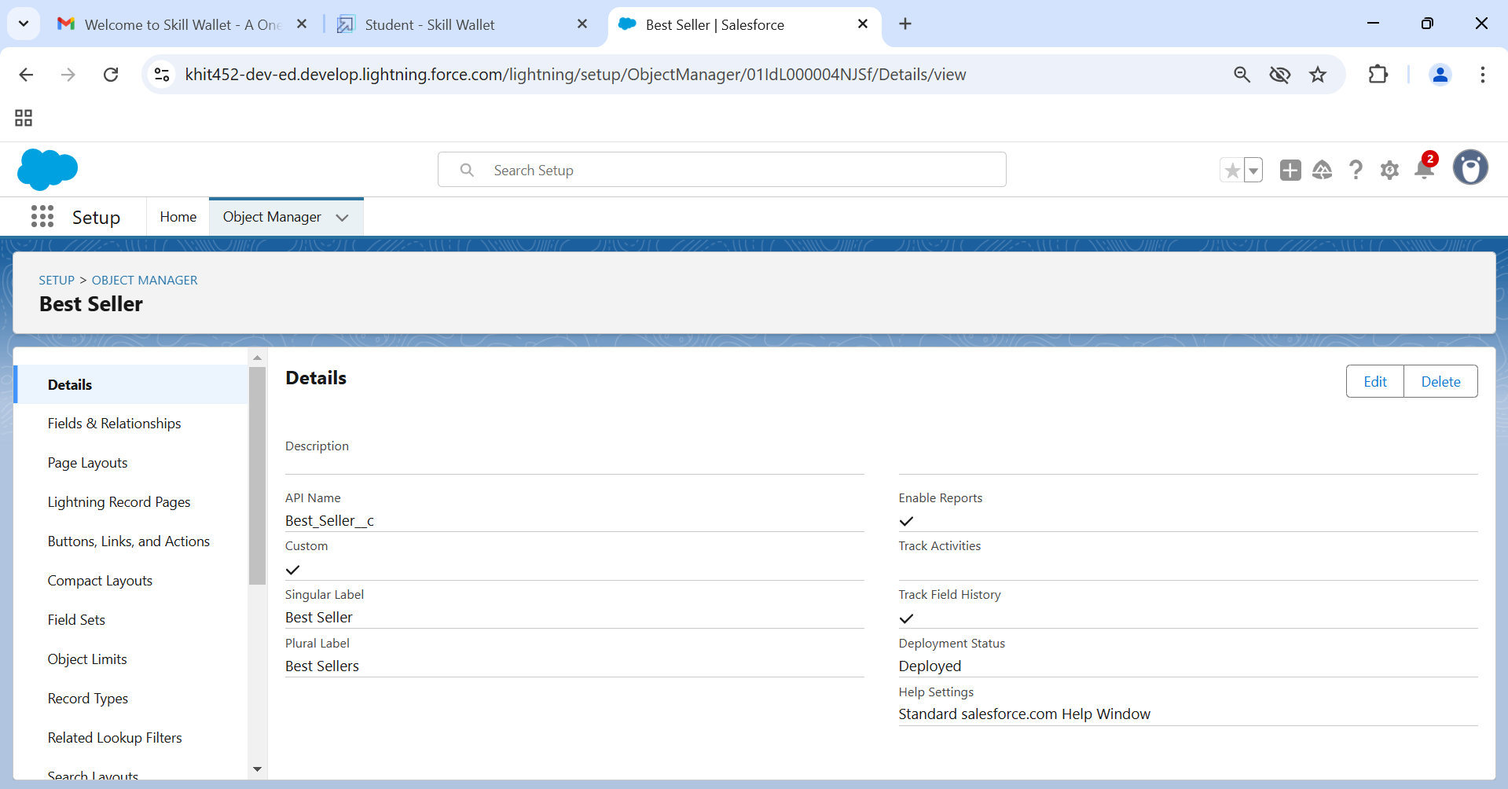

**Custom object for New Launches**

### 

### Custom object for Pizza

### 

### Custom object for Beverages

### 

### Custom object for Mode of Payment

### 

### Tabs

### How to create a tab

### To Create the tab? click on the gear Icon? then click Home button? In the quick find box search for the Tabs.

### Then Click on the new button to create tab, in the Tab style you can select whatever you want to select

### Than select the Customer Detail Object and select the Icon from the search button and click next and save

### Repeat the same Process to create the Remaining Tabs such as,

### Every Day Value

### Best Seller

### New Launches

### Pizzas

### Beverages

### Mode of Payment

### 

**Create App**

### Create the Lightning App

### Go to the Gear Icon? Click on setup? click on the Home Button? Go to the quick find box and select the App Manager

### Fill the app name as Pizza Delivery in app details and branding? Next? App option page keep it as default? Next

### Add Navigation Items add tabs Customer Details, Every Day Values, Beverages, Best Seller, New Launches, pizza and Mode of payment? Next? (Add User Profile) Add System Administrator, Salesforce platform user, Standard User? Next.

### To Add Navigation Items: Select the items from the search bar and move it using the arrow button? Next. select all the tabs which you have created

### To Add User Profiles: Search profiles in search bar? click on the arrow button & select Standard user, standard Platform user & System Admin Profile? save & finish

### 

### Fields & Relationships

### Create the Field for Every Day Value

### Go to setup click on Object Manager type object name in search bar click on the object? Every Day Value? Field and Relationship? then click on new Field Data Type Checkbox

### Go to setup click on Object Manager type object name in search bar click on the object Every Day Value Field and Relationship then click on new Field Data Type Checkbox

### Follow the above steps and create the Remaining Fields.

* Pickup Checkbox
* Select City Picklist (New Delhi, Mumbai, Bangalore, Pune, Chennai, Hyderabad, Kolkata, Noida, Agra, Ahmad Nagar, Ahmedabad, Nasik)
* Select Store Picklist
* Delivery Checkbox
* Pickup Checkbox

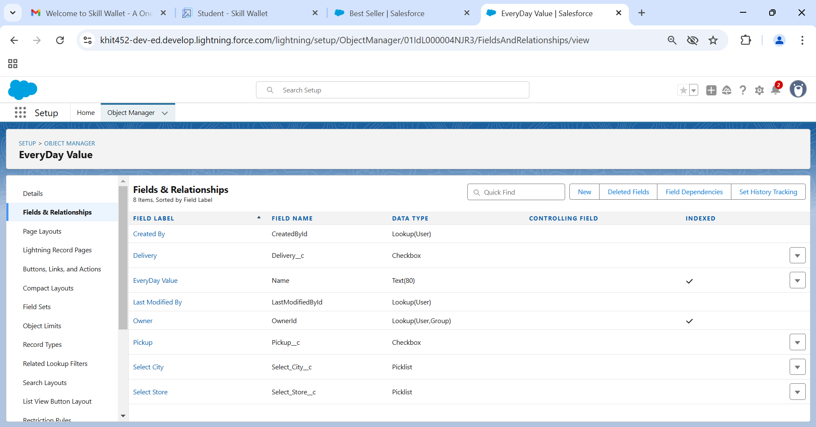

### Create the Field for Best Seller Object

### 

### Create the Field for New Launches

### 

### Create the Field for Pizza

### 

### Create the Field for Beverages

### 

### Create the Field for Customer Detail

Types of Roasted Chicken picklist values:

1. Chicken taco pizza
2. Chicken fajita pizza
3. Chicken pesto pizza
4. Barbecue chicken pizza bread bowl

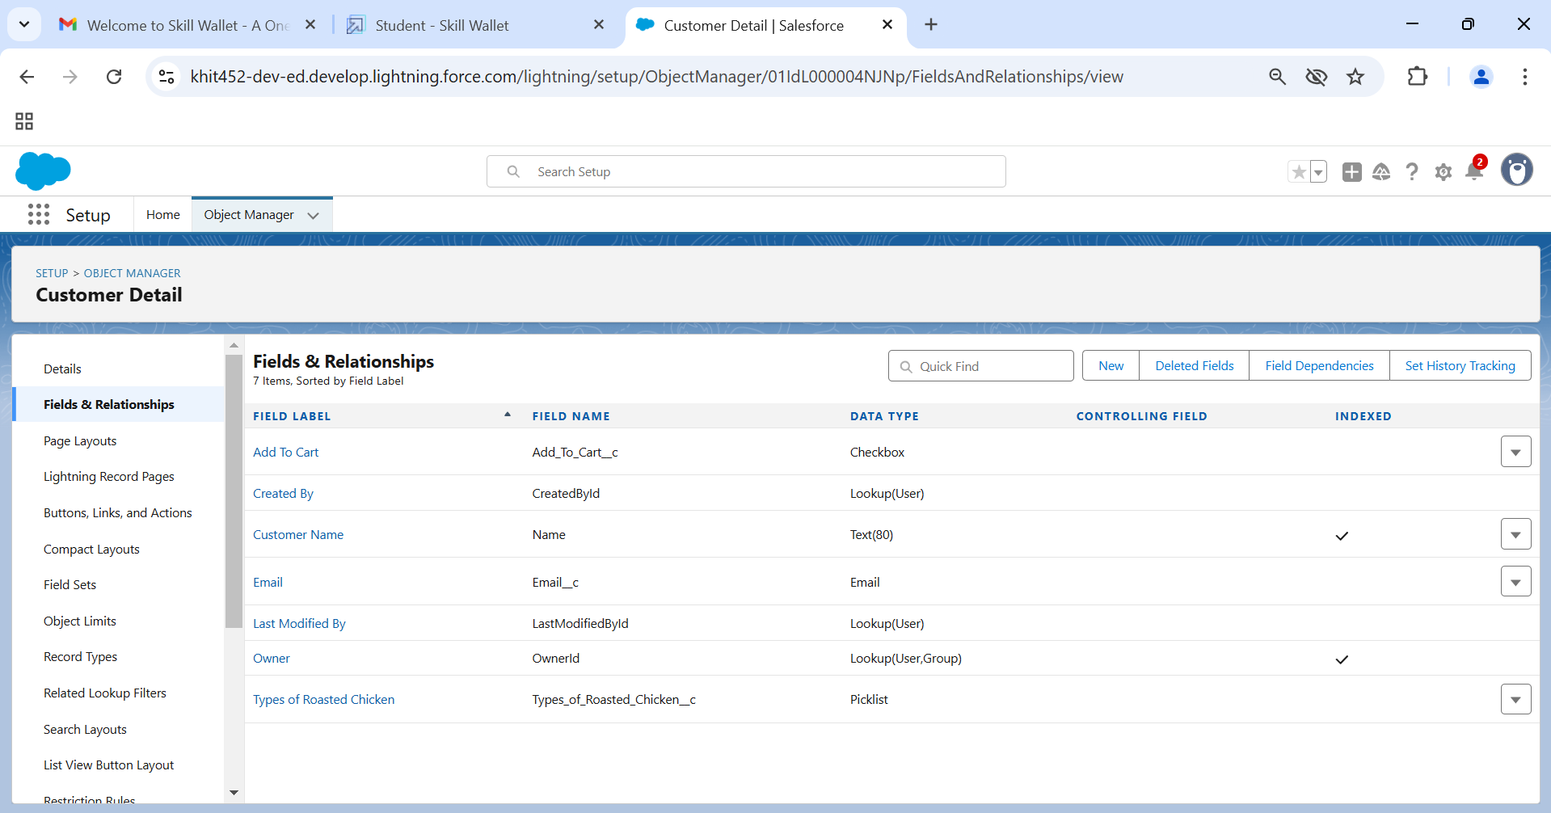

### Create the Field for Mode of Payment

### 

### Record Types

### Record Type for Pizza Object

### Click on the Gear Icon? Then Click on the object Manager? Search for Pizza object? Record Types Click on new Veg Pizza

### 

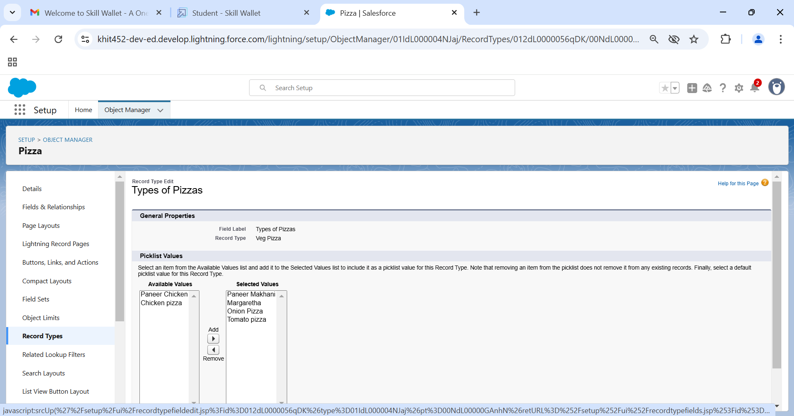

1. Similarly do for the Non-veg and just select the non-veg instead of veg

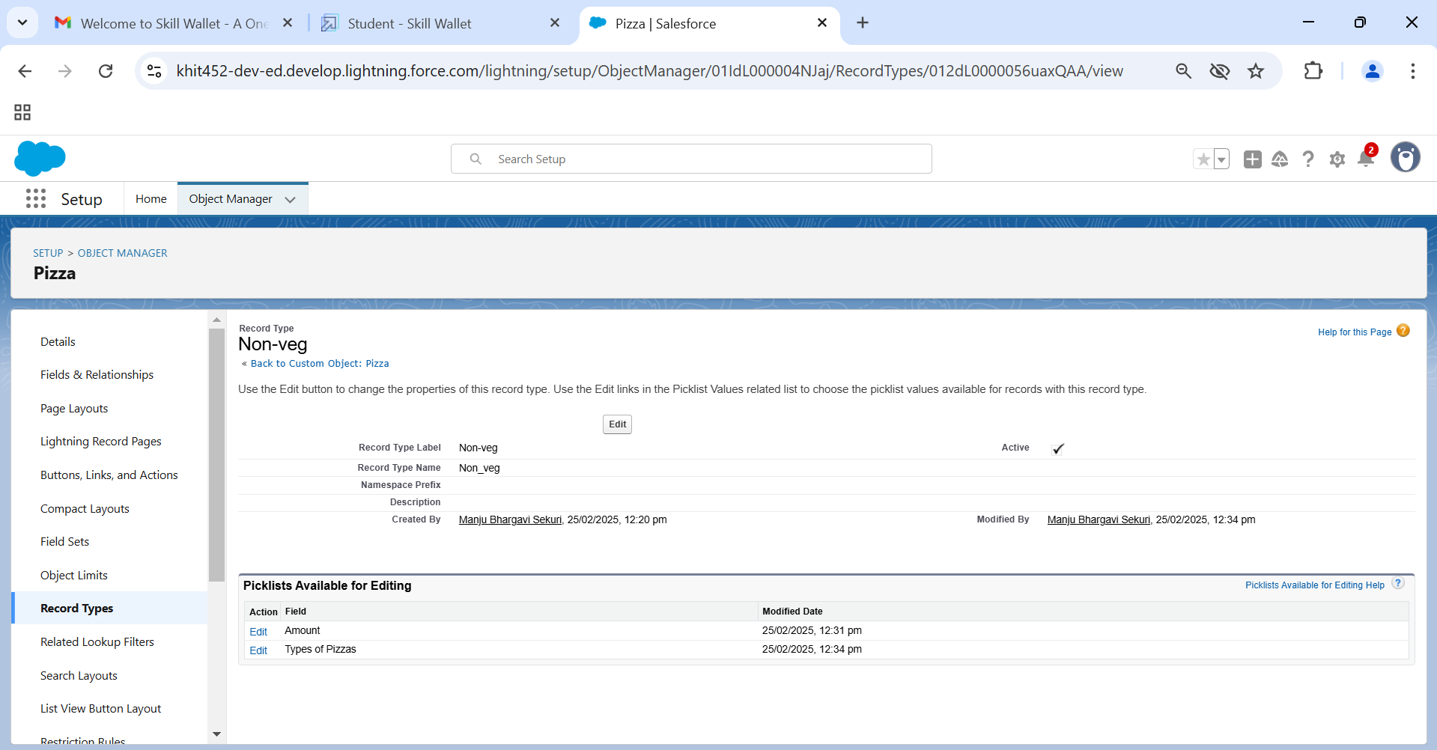

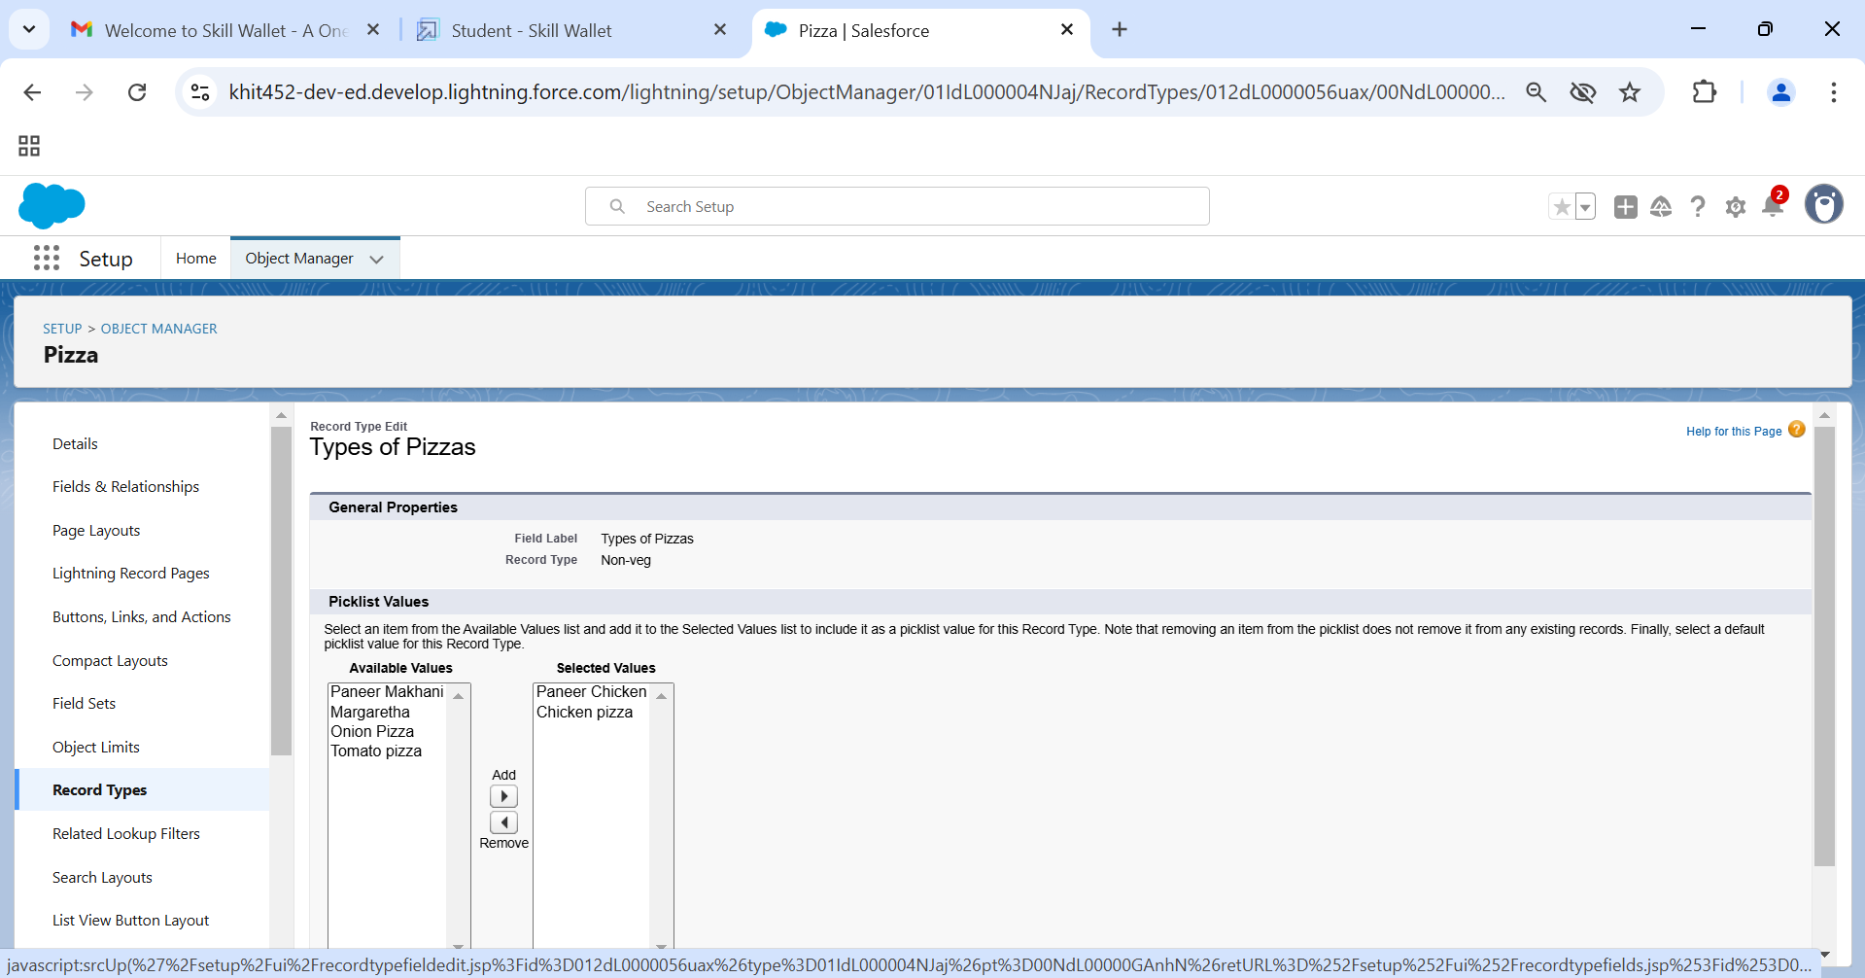

### Profile

### To create a new profile

### Go to setup type profiles in quick find box click on profiles clone the desired profile (standard platform user is pref) and clone that profile

### Enter a Profile Name Sales Manager and click on Save

1. Click on the new created profile
2. While still on the profile page, then click Edit
3. For the sales manager profile give the following access
4. Similarly clone the standard platform profile and give the name as Sales Executive  
   and give the same access to the as of sales manager
5. Again clone the standard User profile and this time give all access for the objects, tabs and field and give the profile name as Delivery Person

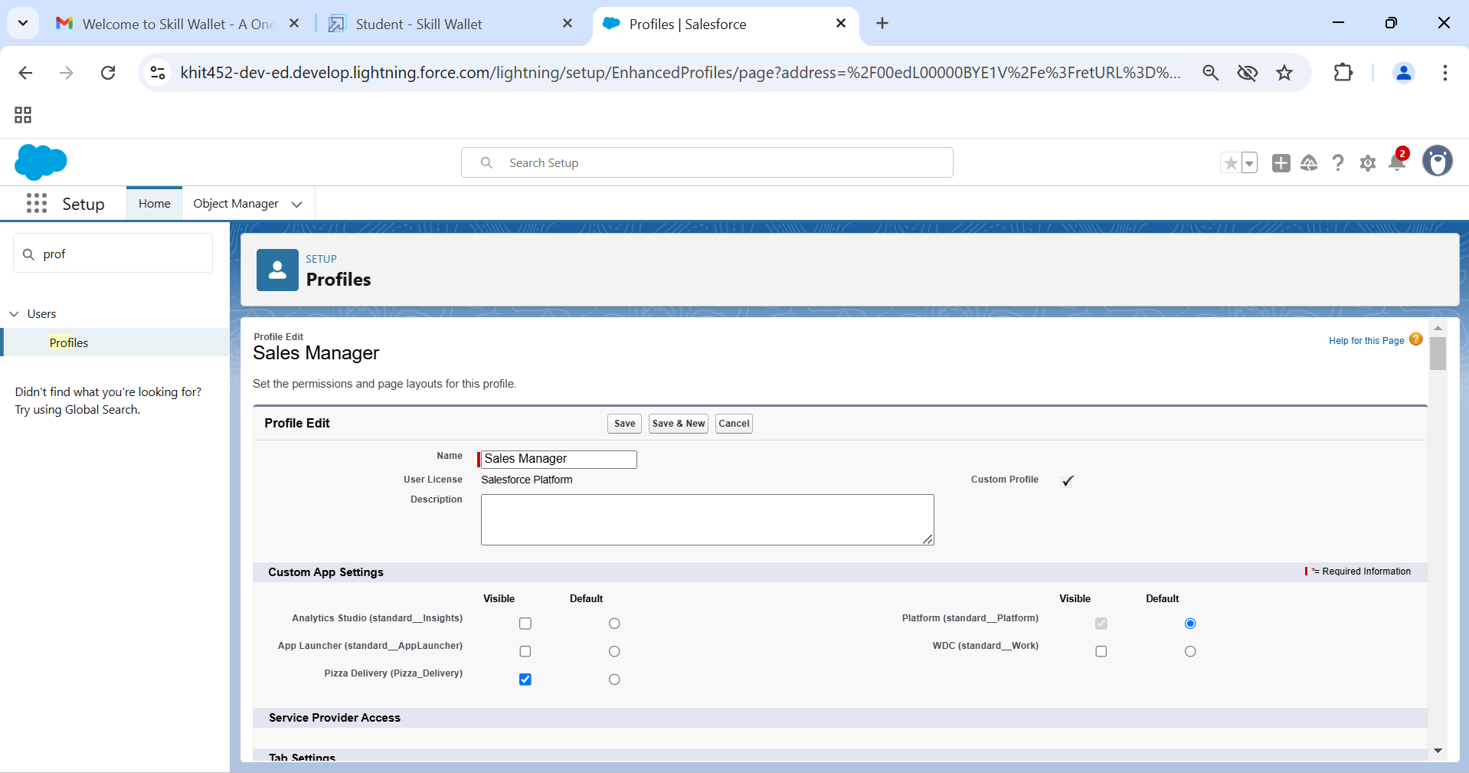

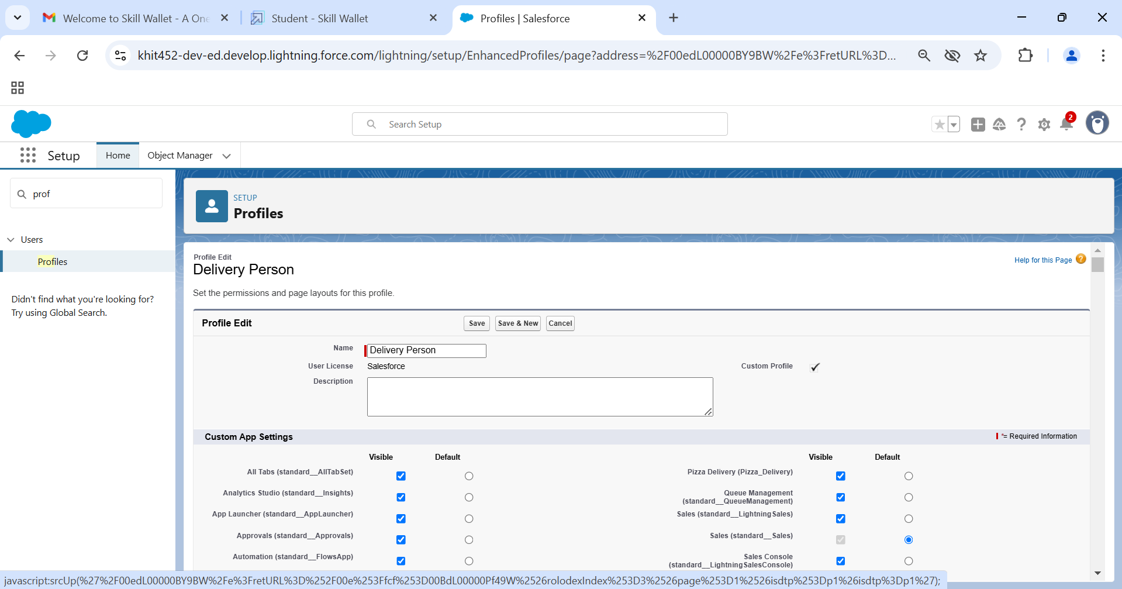

### User Adoption

### Go to the Gear Icon? Click the setup click on the home button and in the quick find box search for the user Click on the user than click on new fill the fields

1. Follow the above and create 2 more user? Marketing manager and Sales Rep

### 

### OWD (Organization Wide Default)

### Create OWD Setting

### Setup, use the Quick Find box to find Sharing Settings.

### Click Edit in the Organization-Wide Defaults area.

### For each object, select the default access you want to give everyone.

1. For Every custom object give private as a record level security.

### 

### Reports

### Go to the gear icon click on the setup click on the home button in the quick fin box search for app manager select the App and go to the navigation

### There select the Report and include in the app than go to App There you will find the Tab

### Click New Report create folder Create the Report Select the Customer with Mode of Payment Object Mode of Payment in the columns Customer detail Created Date columns mode of payment Id and in the rows Mode of payment Mode of payment

### 

### For to the reports and select the customer details with mode of payment.

### Select the following option for the Rows and column.

### You can create the chart as so just click on the chart and you will be able to create it

### 

### 

### 5.Testing and Validation

### Apex Trigger

### Activity- 1

### This Trigger works for the Pizza Object where the scenario is like whenever the customer is selecting the Pizza whether it is veg Pizza or Non-veg Pizza According to the selection of Pizza The Amount will be reflected in the Amount Field.

### Trigger

### 

### Trigger Code:

trigger pizzaApp on Pizza__c (before insert, before update) {

if(trigger.isbefore && trigger.isinsert){

PizzaApplicationHandler.pizza(trigger.new);

//UpdatePizzaApplicationHandler.updatePizza(trigger.new);

}

if(trigger.isupdate){

PizzaApplicationHandler.pizza(trigger.new);

}

**Trigger Handler**

### 

### Trigger Handler code:

public class PizzaApplicationHandler {

public static void pizza(List<pizza__c> pizzaRec){

for ( Pizza__c pz : pizzaRec){

if(pz.name.contains('Margretha') && pz.name.contains('Paneer Makhani') ){

pz.Amount__c = '550';

}

if( pz.name.contains('Paneer Makhani')){

pz.Amount__c = '350';

}

if(pz.name == 'Margretha'){

pz.Amount__c = '200';

}

if(pz.name == 'Tomato Pizza'){

pz.Amount__c = '100';

}

if(pz.name == 'Onion Pizza'){

pz.Amount__c = '100';

}

if(pz.name.contains('Margretha') && pz.name.contains('Paneer Makhani') && pz.name.contains('Tomato Pizza') && pz.name.contains('Onion Pizza') ){

pz.Amount__c = '750';

}

if(pz.name.contains('Margretha') && pz.name.contains('Paneer Makhani') && pz.name.contains('Tomato Pizza')){

pz.Amount__c = '750';

}

if(pz.name == 'Chicken Pizza'){

pz.Amount__c = '400';

}

if(pz.name == 'Paneer Chicken'){

pz.Amount__c = '400';

}

if(pz.name.contains('Paneer Chicken') && pz.name.contains('Chicken Pizza') ){

pz.Amount__c = '800';

}

if(pz.name.contains('Paneer Chicken') && pz.name.contains('Paneer Makhani') ){

pz.Amount__c = '750';

}

if(pz.name.contains('Paneer Chicken') && pz.name.contains('Margretha') ){

pz.Amount__c = '750';

}

if(pz.name.contains('Paneer Chicken') && pz.name.contains('Tomato Pizza') ){

pz.Amount__c = '500';

}

if(pz.name.contains('Paneer Chicken') && pz.name.contains('Onion Pizza') ){

pz.Amount__c = '500';

}

}

}

}

**Schedule Apex**

### Schedule Apex for Frequently visited Customer

### 

public class PizzaDiscountScheduler implements Schedulable {

    public void execute(SchedulableContext sc) {

        // Logic for sending the email

       // if (System.now() == System.DayOfWeek.Sunday) {

           List<Customer_Detail__c> pz = new  List<Customer_Detail__c>();

           String s='gmail.com';

           for(Customer_Detail__c c:pz)

           {

               if(c.Email__c.contains(s))

               {

                   system.debug('haiiiii');

               }

           }

            Messaging.SingleEmailMessage email = new Messaging.SingleEmailMessage();

            email.setToAddresses(new List<String>{'user@example.com'});

            email.setSubject('Special Sunday Discount');

            email.setPlainTextBody('Enjoy a 20% discount on all pizzas today!');

            Messaging.sendEmail(new List<Messaging.SingleEmailMessage>{email});

             }

}

**Activity-2**

### Click on the Gear Icon? Go to the Home Tab in the Quick Find Box Search for Apex Class.

### Click on the Schedule Apex Give Job Name as Schedule Pizza.

### Click on Apex Class Lookup Select Pizza Discount Scheduler I n Recently Viewed Apex Class.

### In Frequency Click on the Weekly Radio button You can Select the Start Date and End date As Per You Requirement and then Click on the Save Button.

### 

### Click on the debug besides file Click on the Open Execute Anonymous Windows Execute the below code

### 

### // Schedule the job to run every Monday at 8 AM

### String cronExp = '0 0 8 ? * SUN';

### // Create an instance of the ExpenseReportProcessor class

### PizzaDiscountScheduler expenseProcessor = new PizzaDiscountScheduler();

### // Schedule the job using the System.schedule method

### System.schedule('Expense Report Processor', cronExp, expenseProcessor);

**6. Key Scenarios Addressed by Salesforce in the Implementation Project**

**1.Order Management**

* Track customer orders from start to finish.

**2. Customer Support**

* Handle customer complaints and issues (like wrong orders) quickly through chat, email, or phone.

**3. Personalized Offers**

* Send special discounts or offers to customers based on their past orders.

**4. Driver Management**

* Assign delivery drivers to orders and track their location in real-time.

**5. Inventory Management**

* Keep track of ingredients and automatically reorder when stock is low.

### 7.Conclusion

* A comprehensive **Pizza Delivery Application** has been successfully developed using Salesforce, offering a streamlined process for managing orders, deliveries, and inventory.
* **Key features** like real-time order tracking, automated inventory management, and delivery performance monitoring have been implemented.
* **Salesforce’s powerful platform** has enabled the development of a scalable, automated, and efficient system that enhances the operational efficiency and customer satisfaction of the pizza delivery business.